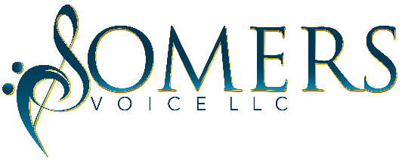
VENDOR REGISTRATION FORM

Somers Voice LLC presents “Sistas The Musical” – Written By Dorothy Marcic. This show will take place at the Hylton Performing Arts Center – Gregory Family Theater - George Mason University – Manassas, VA. Vendors will select a show date below. This show has no intermission. Your business will be assigned a location to set up. Electricity is not provided. Vendors must bring their own table and any other items needed. Due to Covid restrictions, no food vendors are allowed.
Setup Time: One hour prior to the show.
Breakdown Time: No later than 30-minutes after every show
Please select the show time(s) below where you’d like to be a vendor:
Show Dates: Friday - November 5, 2021 @ 7:00 p.m. ____
Saturday - November 6, 2021 @ 2:00 p.m. _____ 7:00 p.m. ____
Sunday - November 7, 2021 @ 3:00 p.m. _____
Saturday - November 13, 2021 @ 2:00 p.m. _____ 7:00 p.m. ____
Sunday - November 14, 2021 @ 3:00 p.m. _____
Booth fee is $100 per business, $75 for nonprofit organizations (e.g., churches, social services, government, etc.) Payments can be made payable via check to: Somers Voice LLC. For other payment methods please use the contact information below.
Vendor fees are non-refundable. All vendor forms and fees must be received by October 18, 2021. Each vendor reservation received will be notified via email once approved. Vendors are responsible for their own personal property and are responsible for maintaining compliance with codes and regulations of The Hylton Performing Arts Center. All vendors assume complete liability and responsibility for their participation in the event. Each vendor must have their area cleaned by 30-minutes after the end of the show.
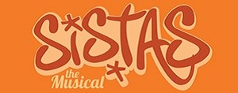
For additional information and to submit ad(s):
Email: somersvoice@gmail.com or call 703.831.7799
Sign here agreeing to the terms:
Name: ______________________________ Date: ____________________________

